|  |  |  |
| --- | --- | --- |
|  |  | Information and communication technology  SBA Report  Topic: Composition Analyzer  **Name: HO YIN HEI**  **Class: 6E**  **Class No: 11** |

Contents

Introduction 3

Algorithm design 3

Finding the frequency letter 3

Finding the frequency of word 3

Calculation of the total number of words 3

Calculation of the total number of sentences 3

Calculation of the total number of paragraphs 3

Calculation of the total number of function word 3

The library used in the program 3

Conclusion 4

Source code 4

Acknowledgement 4

Reference 4

# Introduction

(At least 50 words)

* My program provides several functions, such as counting the total number of words, characters, letters, sentences, paragraphs, function words and finding the frequency of a specific word.
* A screenshot of a computer program

  Description automatically generated
* The above image is the screen capture of the menu.
* Briefly describe the following paragraphs

# Algorithm design

## Finding the frequency letter

* A screenshot of a computer program

  Description automatically generated
* This program will calculate the frequency of letters inside your text from the start of the text.
* Explanation on how it works: The counting value will start with 0. It selects from chr(65) (which is the letter “a”) to chr(91) (which is the letter “z”) and check every letter in your text. If the letter matches, the counting value will add 1 and then move on to the next letter on the text. When all letters inside the text are checked, it will print the total number of the letter which it is currently counting and then move on to the next letter and check if any letters in the text matches until the letter “z” has also finished counting.
* A computer screen shot of a program code

  Description automatically generated

## Finding the frequency of word

* Flowchart/Pseudocode
* Screen Capture

## Calculation of the total number of words

* A screenshot of a computer

  Description automatically generated
* This program will calculate the total number of words inside your text from the start of the text.
* Explanation on how it works: First, it splits up the text into a lot of single words. Next, it counts the number of single words that’s been split from the text. Finally, it prints out the amount of single words that’s been split from the text.
* A computer screen shot of text

  Description automatically generated

## Calculation of the total number of sentences

* A screenshot of a computer screen

  Description automatically generated

End Sub program

* This program will calculate the total number of words inside your text from the start of the text.
* Explanation on how it works: First, it counts the number of full stops, question marks or any symbols which ends the sentence. Next, it counts the number of special cases that also uses the symbols but does not end the sentence such as “Dr.” and “Mr.” After that, the program adds up the symbols and then subtract the number of special cases that does not count as a sentence ending symbol. Finally, it prints out the number of sentences in the text.
* 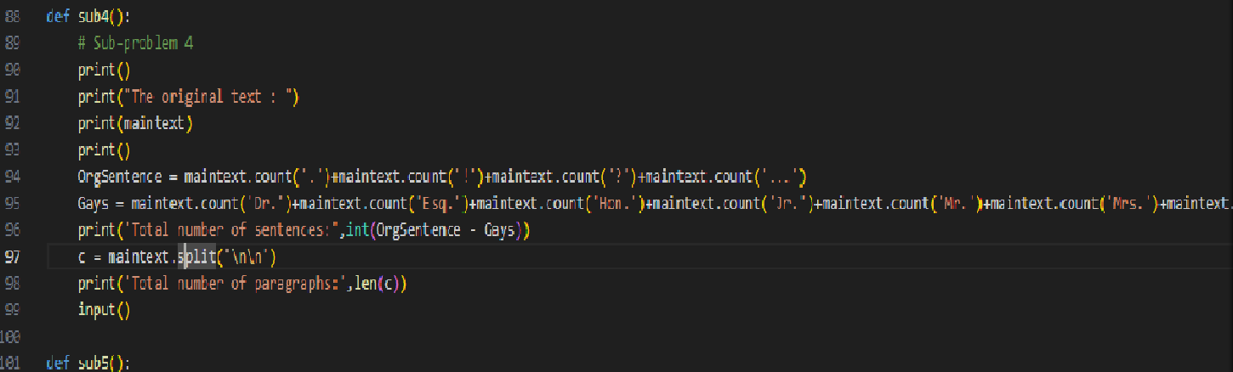

## Calculation of the total number of paragraphs

* This program will calculate the total number of paragraphs in the text.
* Explanation on how it works: First, it splits the text by separating lines since we usually start a new column for a new paragraph. Then, it counts the number of texts split.
* A screen shot of a computer code

  Description automatically generated

## Calculation of the total number of function word

* Function word means a word whose purpose is to contribute to the syntax rather than the meaning of a sentence, for example, in “We do not live here”, “do” is the function word.
* This program will calculate the total number of function words in the text.
* Explanation on how it works: First, it made a table of most possible function words that would occur in the text. Then, it loops through all the function words in the list and then count the amount of that specific function word appears in the text. If the number of that function word appears once or more than once, the program prints out the amount of that function word appears on the text.

## The library used in the program

* Have you used any library? Name of them.
* Their purpose and advantages

# Conclusion

(At least 50 words)

* What have you learned?

# Source code

|  |
| --- |
| Paste the source code here  Change font style: Courier New |

# Acknowledgement

# Reference